

**E-Smart Restaurant**

**Mobile Application**

User’s Manual

**Contents:**

1. Starting application …………….. 3-6

* Login
* Login as Waiter

Dashboard

1. New Order ………………………7-10

* Merge table

1. Existing Order ……………………11-17

* Split Table
* Shift Table
* Order send to Kitchen

1. View Order ……………………….18-19
2. Take Away ……………………….20-21
3. Menu ……………………………..22
4. Bill ……………………………....23
5. Setting ……………………………25

* Sign Out

1. Login as Kitchen ………………….26-27
2. **Starting Application**

To start Central Model School App, follow the given steps:

1. Click on Central Model School App icon on application menu.
2. On clicking the Central Model School App icon, the application starts and display Login page. The Login page contains the following options:
3. Role [Manager, Waiter, Kitchen]
4. User Name
5. Password
6. After filling the above details, click on the SUBMIT button.
7. If the information is valid the login is successful and Dashboard is displayed.

Login

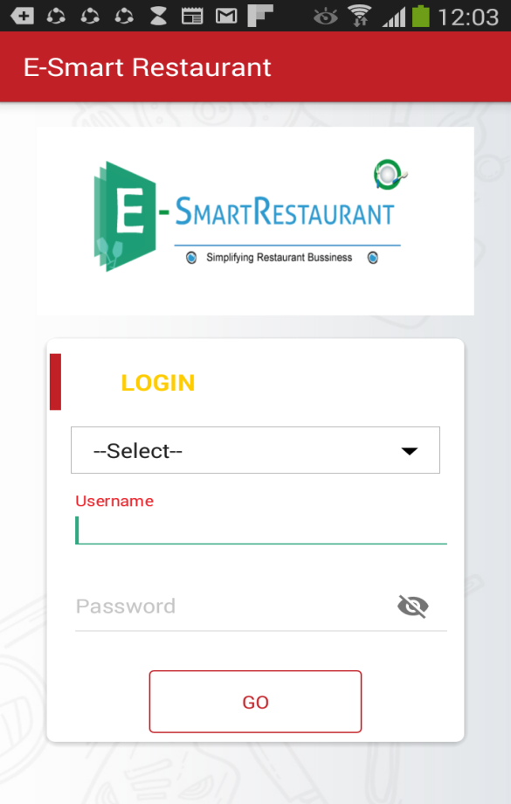 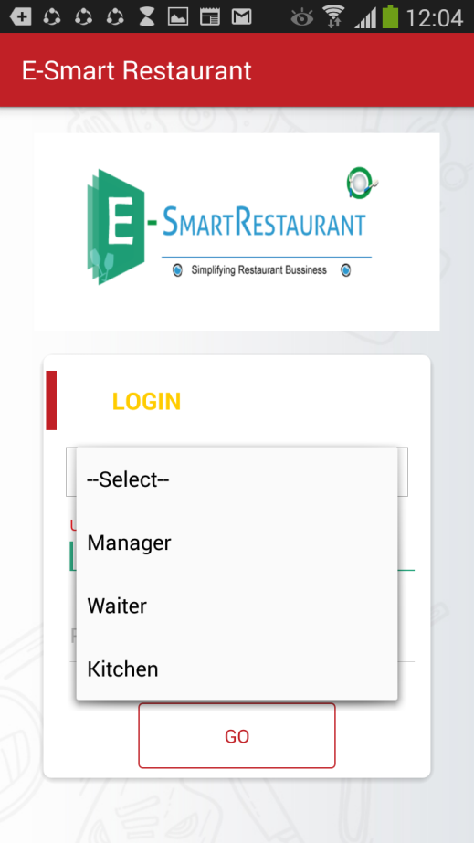

Select Usertype

Select Role

* Login as Manager

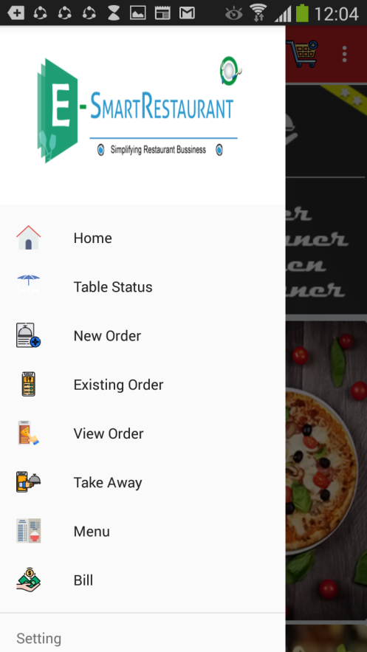

1. The Drawer contains the following options. Each of these icon is a link to the respective section:

* Home
* Table Status
* New Order
* Existing Order
* View Order
* Take Away
* Menu
* Bill
* Amount wise Pie chart
* Quantity wise pie chart
* Setting
* Logout

1. **New Order** 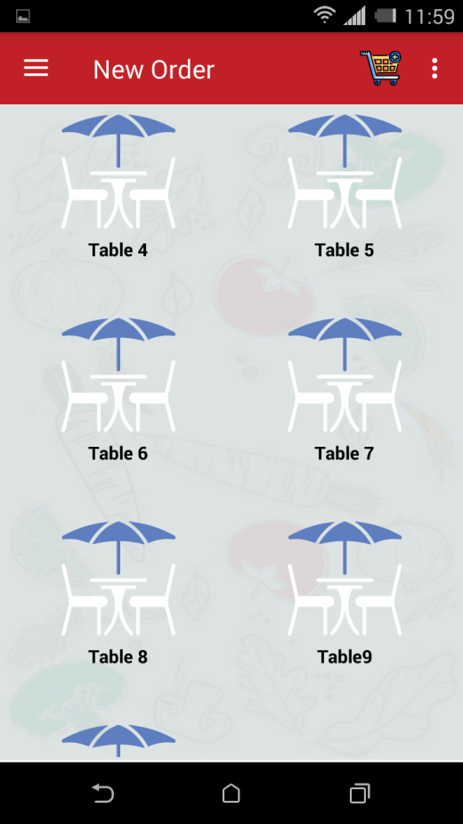

Select New Order from options

Select Table

To take new order, follow the following steps:

* Select New Order from Dashboard.
* Select Table.
* Enter No. of peoples on that Table & save it.
* Now select Menu from menu list for that table, Add description of food such as less spicy, with extra butter etc. if want.
* After selecting Menus it will add to chart.

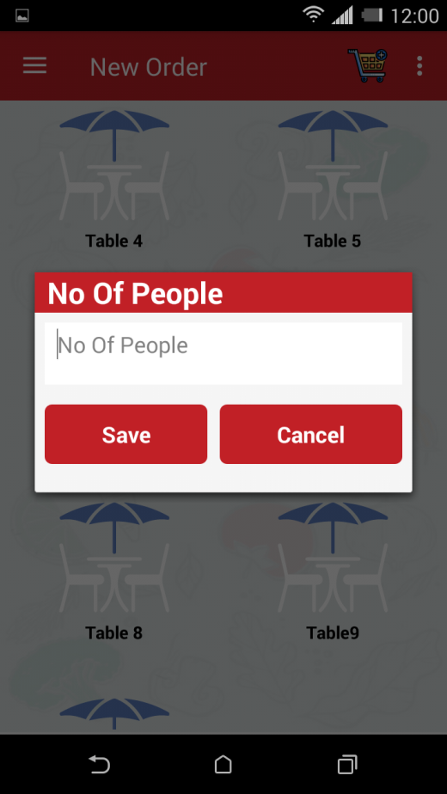 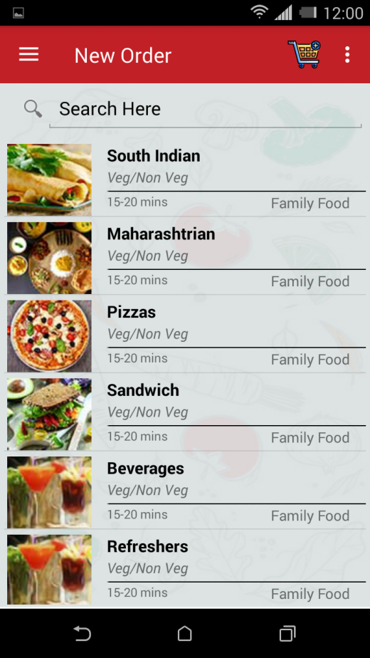

Select Menu.

Enter No. of people.

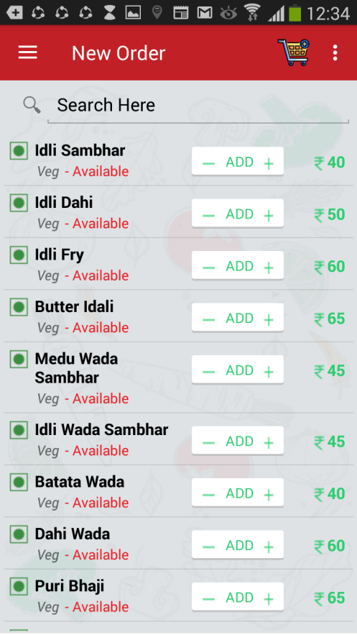 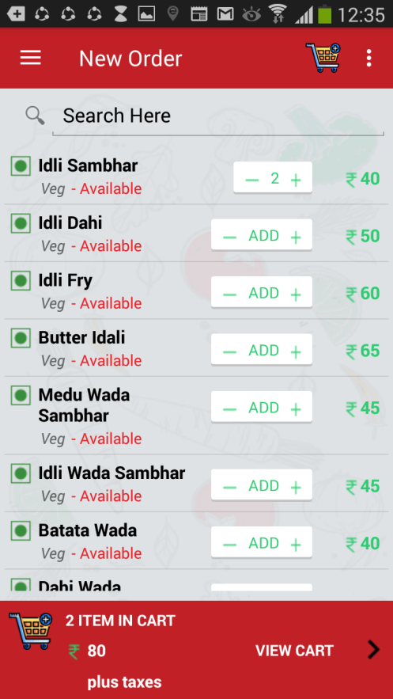

View Cart option

Add No. of plates

Order will add to cart

* **Merge table**  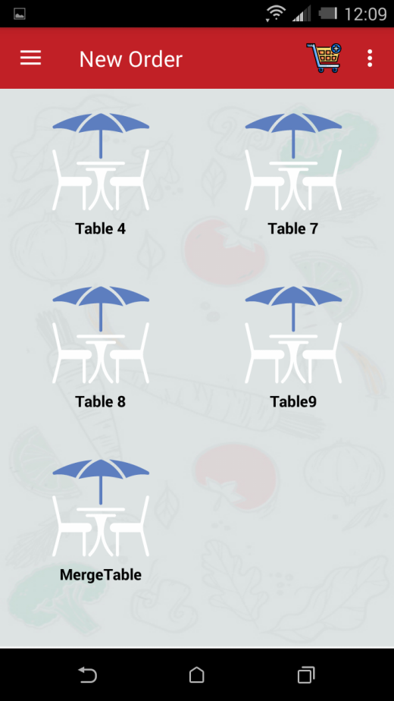 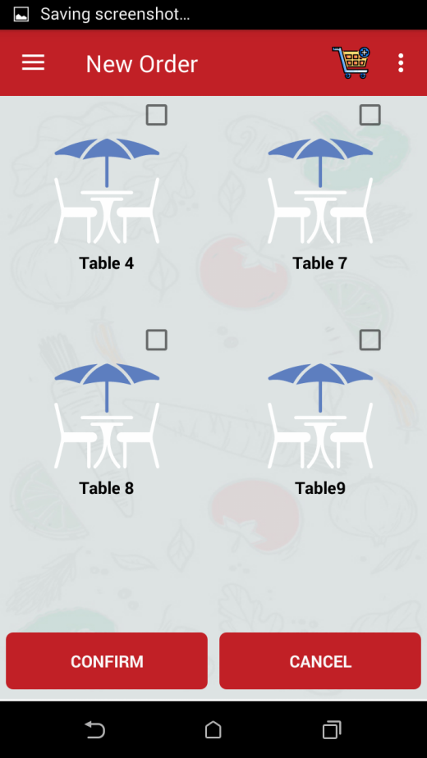

Select Table to be merge

Select Merge Table to merge tables

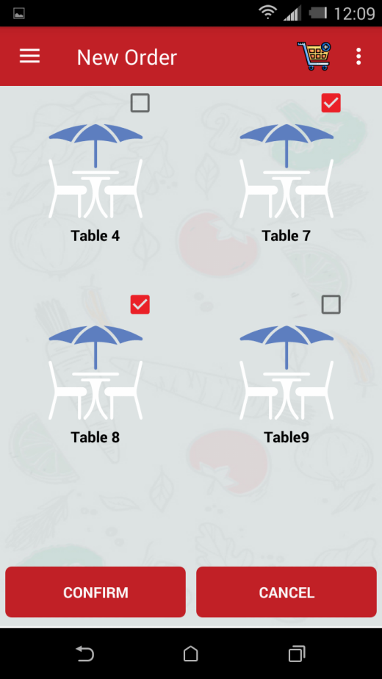 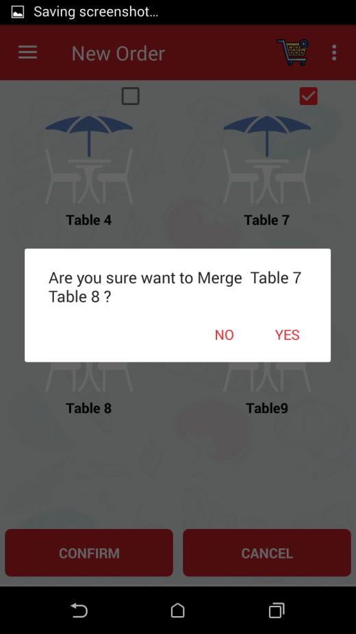

Select yes to merge table

Confirm to merge selected tables

* Now take order for Merge Table by selecting menu.

1. **Existing Order**

To see existing order follow the steps:

* Select Existing Order from dashboard.
* Select table to see existing order of that table.
* If Customer wants to add new order so we can add from ADD Order tab.
* When order will complete, select VIEW Order tab to send it to the Kitchen.
* Kitchen will get Notification for preparation of order.



Select Existing Order

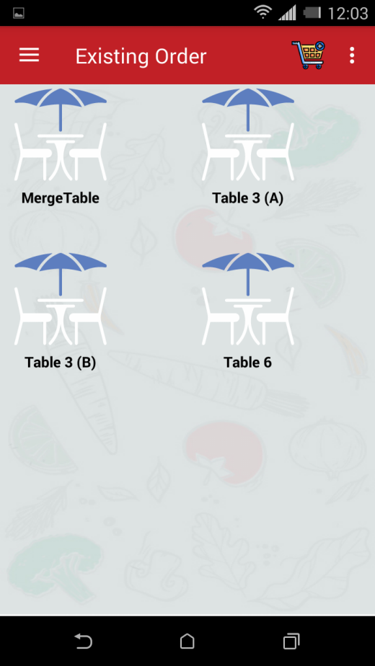 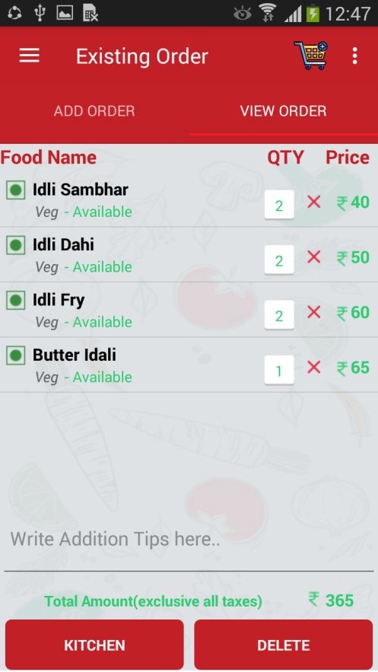

Send Order to Kitchen

Select Table to see Order

**Sharing & Split table:**

1. Split Table

* Long Press on Table to split it into two.
* Select Split.
* Select yes to split table, otherwise select No.
* Now enter No. of people, take order by selecting Menu from menu list.
* Now we can see table is split into two tables as (A) & (B).
* Take different order for different table.

 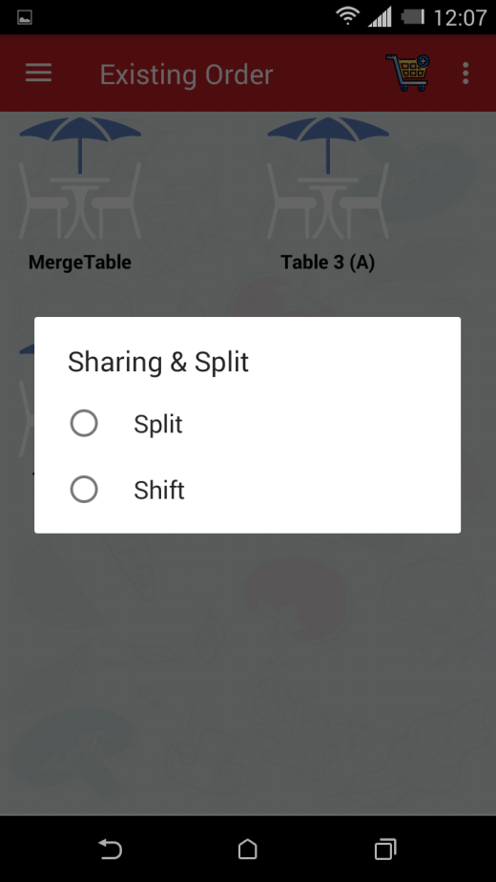

Select split

Select Table 6 to split it.

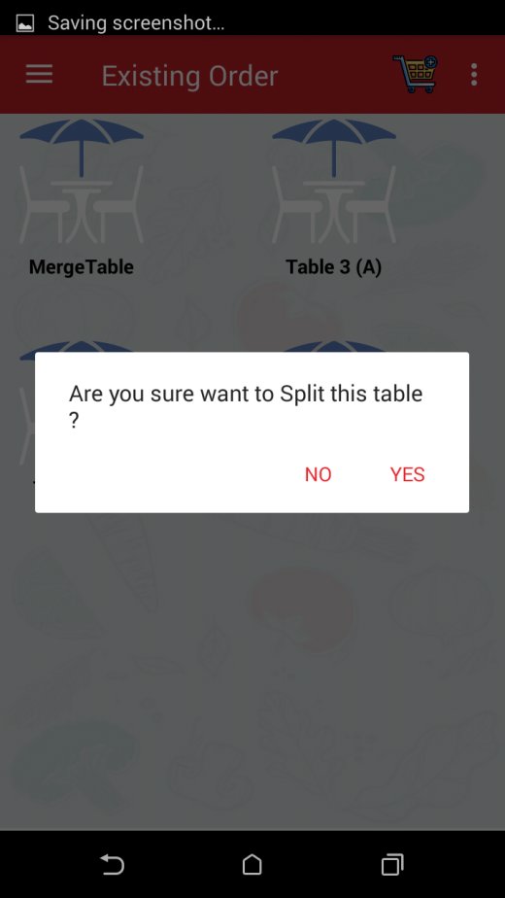 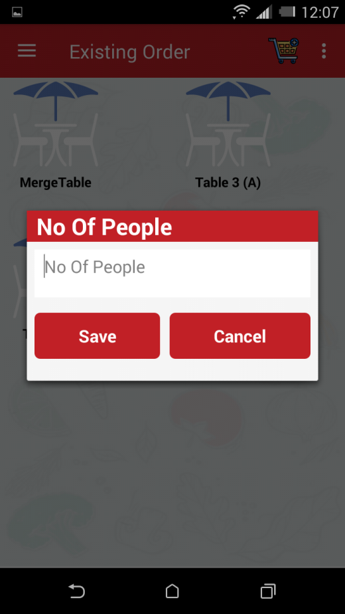

Add No. of People.

Select Yes to Confirm.

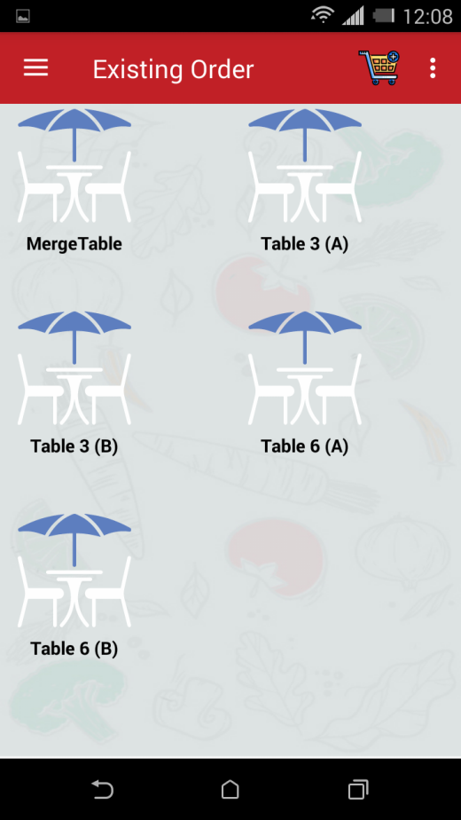

Table 6 is split into Table 6 (A) & Table 6 (B)

Select Menu & add food description

1. Shift Table

* Long Press on Table to shift it to other.
* Select Shift.
* Select yes to shift table, otherwise select No.
* Now select table from existing table to shift on that.
* Select yes if sure to shift table, otherwise select No.
* Now we can see table is shifted.

 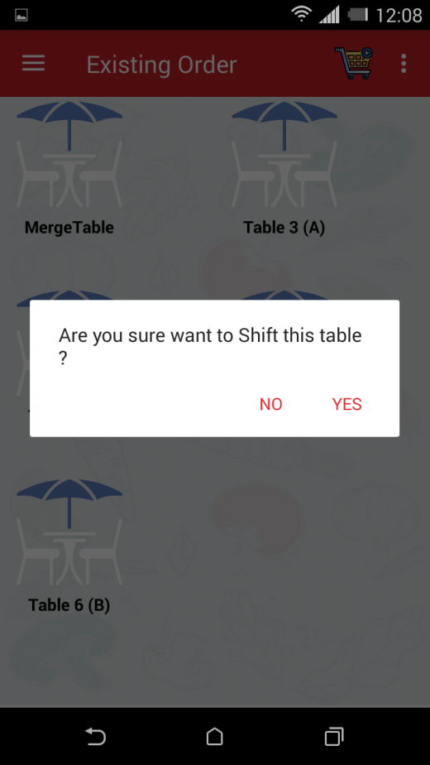

Select yes to confirm

Select Table to be shift.

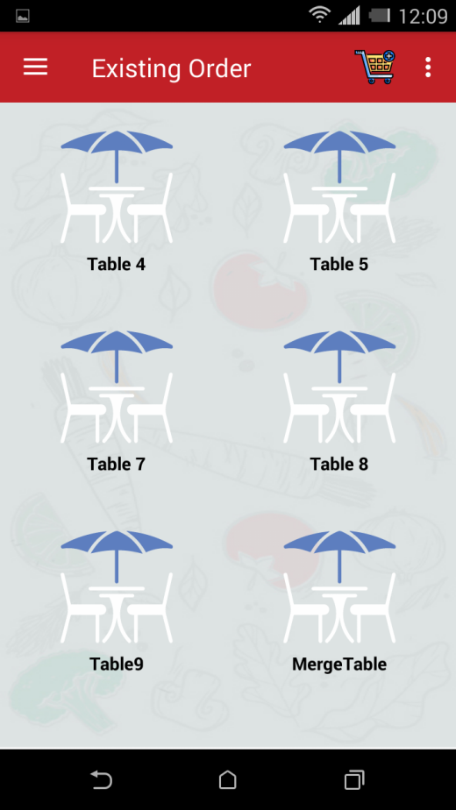 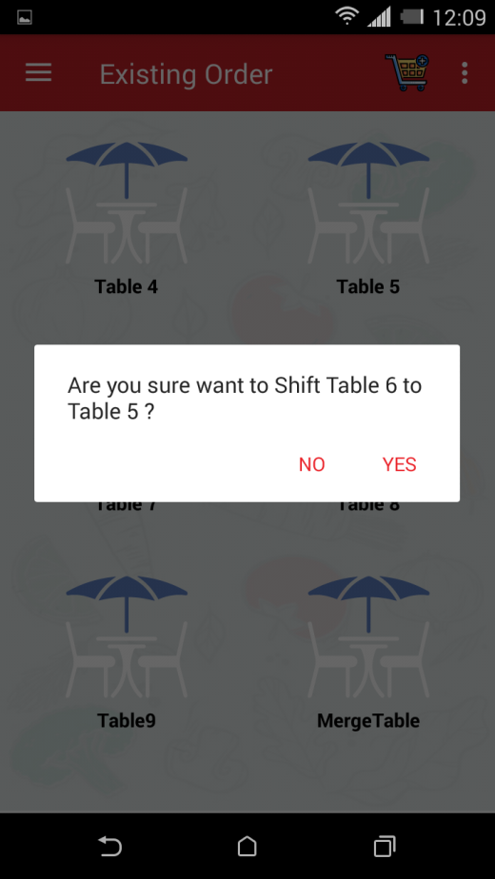

Select Yes

Select destination Table.

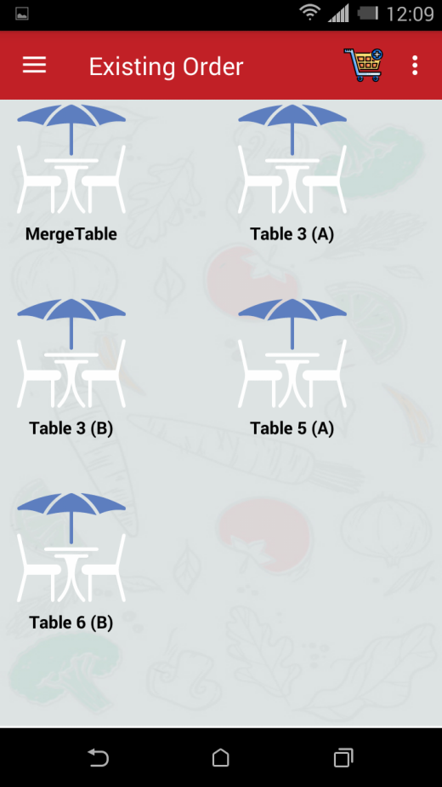

Table is shifted from Table 6(A) to Table 5(A)

1. Order send to kitchen

* From Existing Order select View Order, now select Kitchen to send order.
* Kitchen will receive Notification



Select Kitchen to send order

1. **View Order**

To view order, follow the steps:

* Select View Order from Dashboard or we can select cart to view order.
* Table wise order is given, by selecting Table we can View the order.

 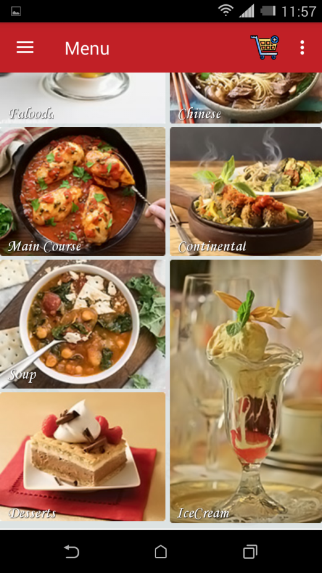

Select View Order

Select View Order

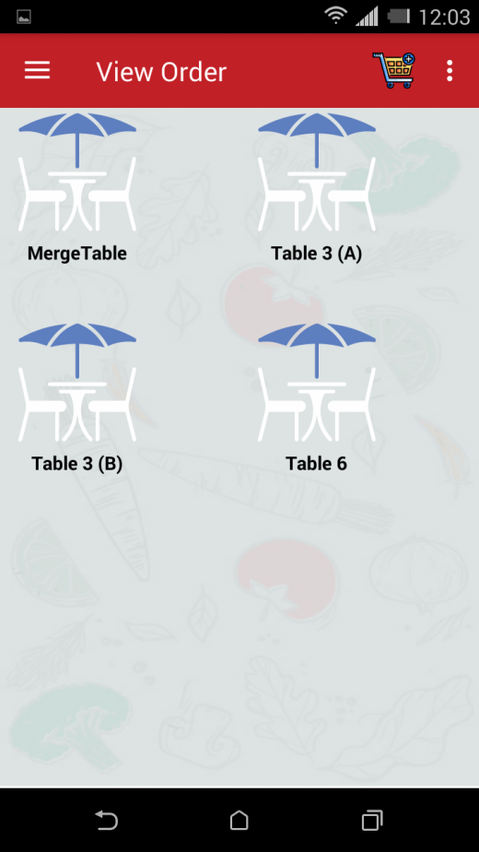 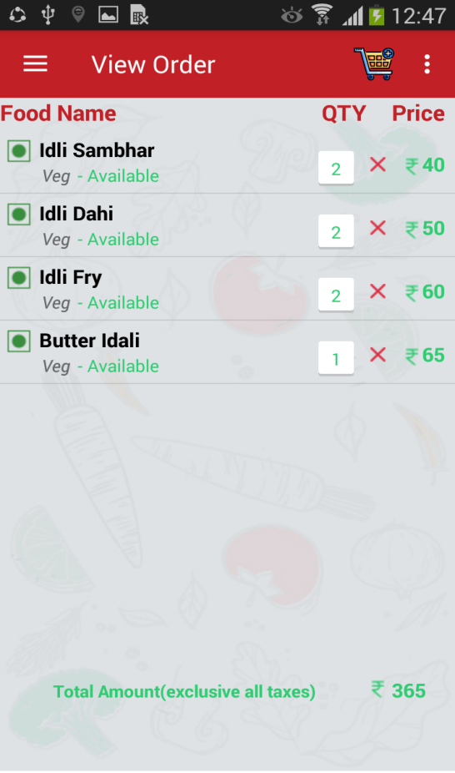

Select Table to view order of that Table

1. **Take Away**

To take away order, follow the steps:

* Select Take Away from dashboard.
* Fill the details & sign up.
* Select menu from Menu list.
* Send order to kitchen.

 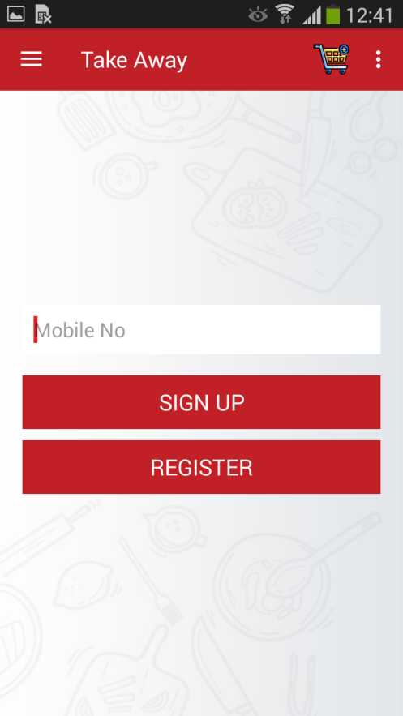

Select Take Away

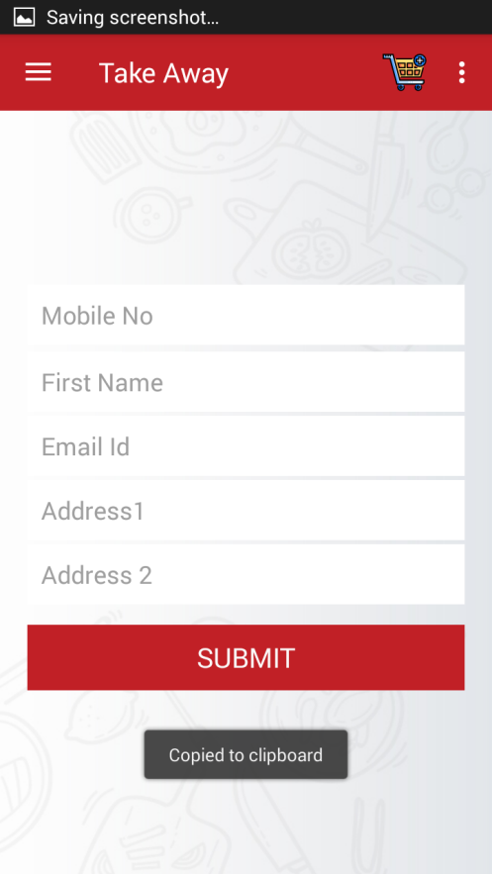 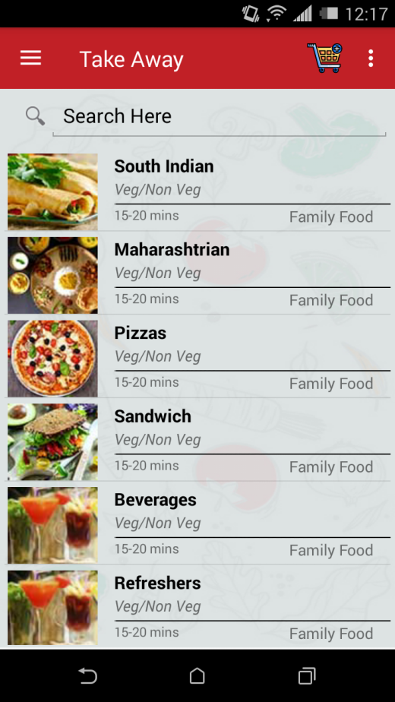

Select Menu

From View Order send order to Kitchen

1. **Menu**

 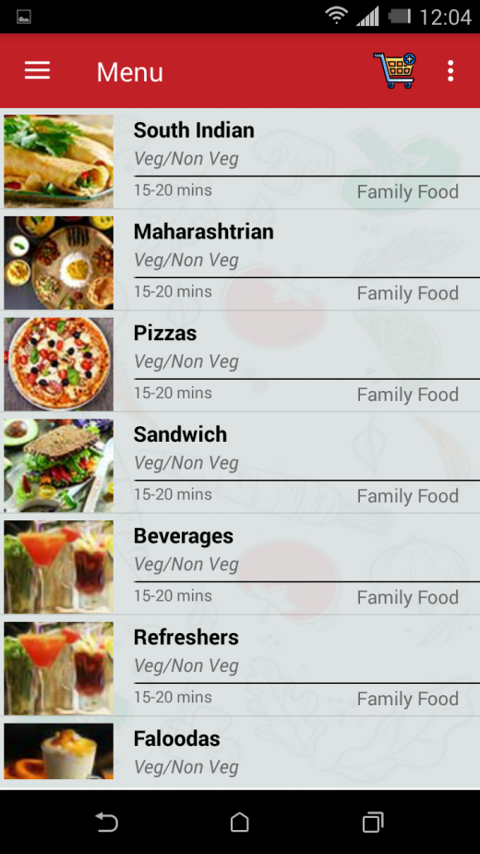 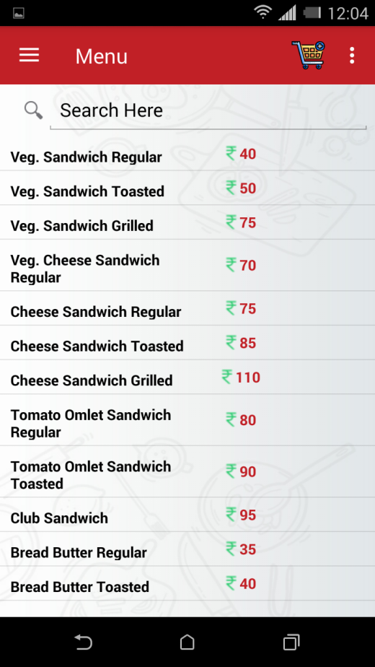

Menu with price.

View different Menu

Select Menu from Dashboard

1. **Bill**

To view Bill, follow the steps:

* Select Bill from dashboard.
* Select table to view bill.
* Bill will generate with Total Amount (Exclusive all taxes).

 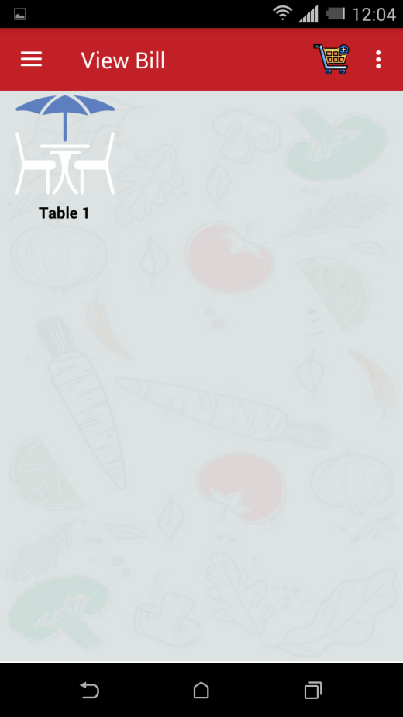

Select Bill from Dashboard

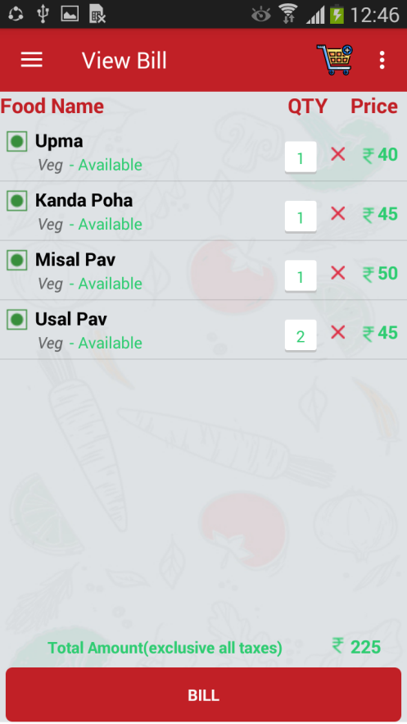

1. **Amount wise chart**

**It will show top 10 Food name which has been sold between two days (date given by you) acc to amount .**

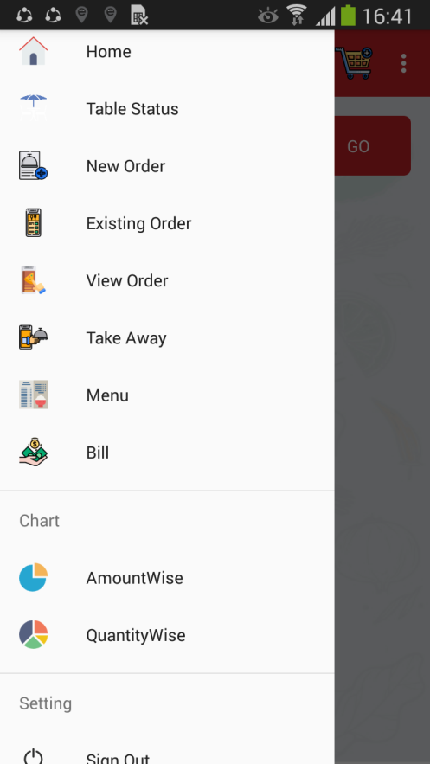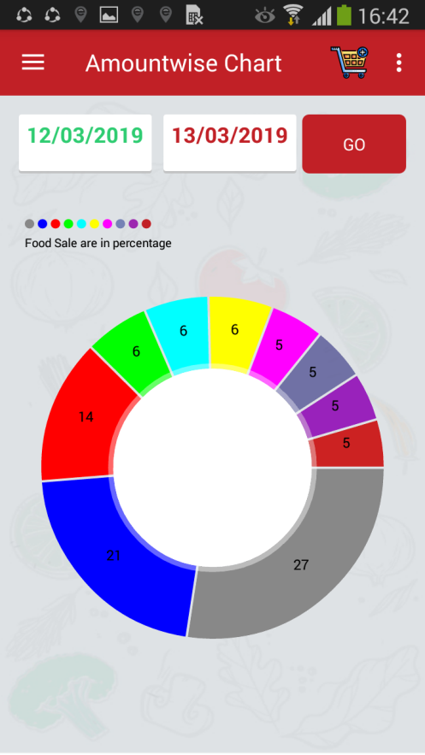 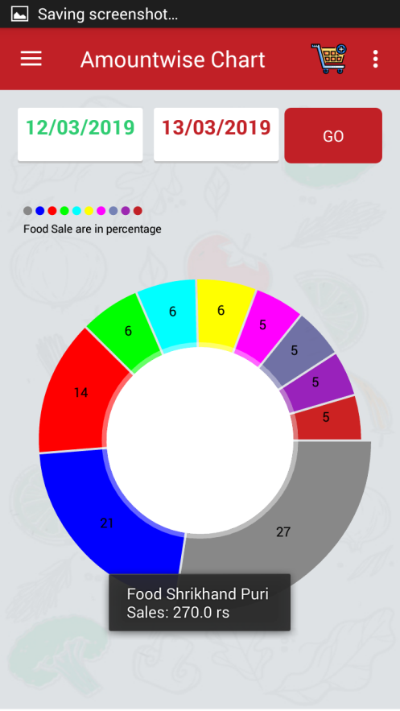

Select Amount wise

1. **Quantity wise chart**

**It will show top 10 Food name which has been sold between two days (date given by you) acc to quantity .**

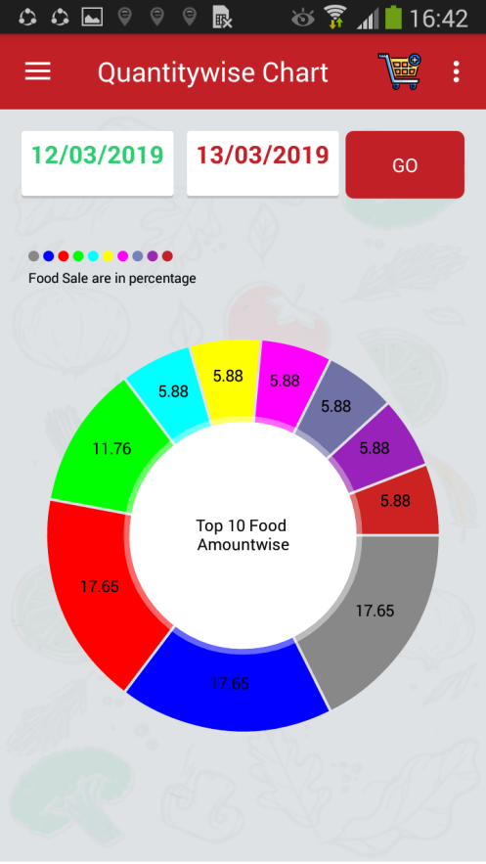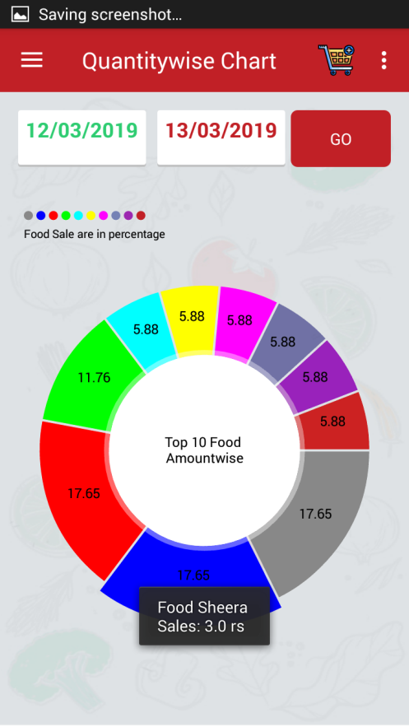

Select Quantitywise

1. **Setting**

**Sign Out**

To Sign out follow the steps:

* Select Sign Out from dashboard.
* Select yes to confirm.

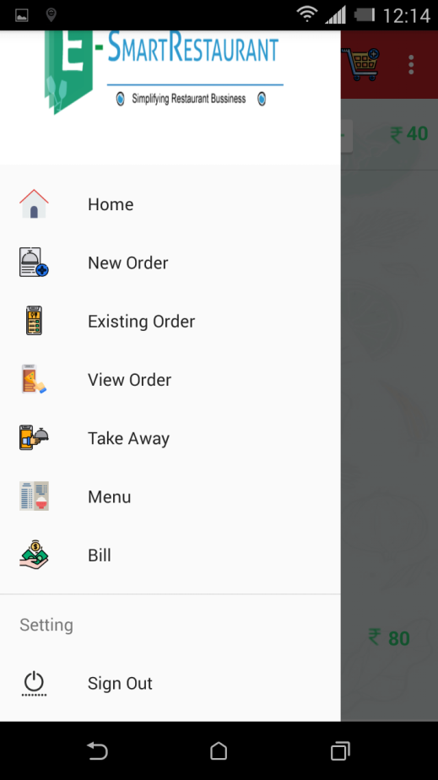 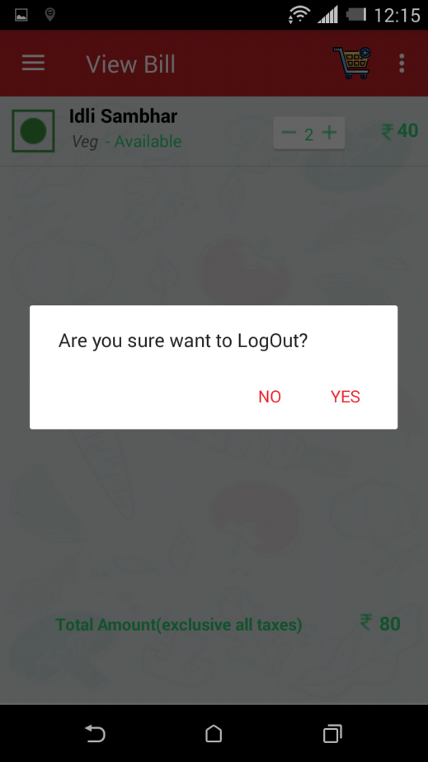

Select syes to confirm

Select Sign Out

* Login as Waiter



Drawer Options

**1.**

The Drawer contains the following options. Each of these icon is a link to the respective section:

* Home
* Table Status
* New Order
* Existing Order
* View Order
* Take Away
* Menu
* Bill
* Setting
* Logout

**2.New Order** 

Select New Order from options

Select Table

To take new order, follow the following steps:

* Select New Order from Dashboard.
* Select Table.
* Enter No. of peoples on that Table & save it.
* Now select Menu from menu list for that table, Add description of food such as less spicy, with extra butter etc. if want.
* After selecting Menus it will add to chart.

 

Select Menu.

Enter No. of people.

 

View Cart option

Add No. of plates

Order will add to cart

* **Merge table**   

Select Table to be merge

Select Merge Table to merge tables

 

Select yes to merge table

Confirm to merge selected tables

* Now take order for Merge Table by selecting menu.

**3.Existing Order**

To see existing order follow the steps:

* Select Existing Order from dashboard.
* Select table to see existing order of that table.
* If Customer wants to add new order so we can add from ADD Order tab.
* When order will complete, select VIEW Order tab to send it to the Kitchen.
* Kitchen will get Notification for preparation of order.



Select Existing Order

 

Send Order to Kitchen

Select Table to see Order

**Sharing & Split table:**

1. Split Table

* Long Press on Table to split it into two.
* Select Split.
* Select yes to split table, otherwise select No.
* Now enter No. of people, take order by selecting Menu from menu list.
* Now we can see table is split into two tables as (A) & (B).
* Take different order for different table.

 

Select split

Select Table 6 to split it.

 

Add No. of People.

Select Yes to Confirm.



Table 6 is split into Table 6 (A) & Table 6 (B)

Select Menu & add food description

1. Shift Table

* Long Press on Table to shift it to other.
* Select Shift.
* Select yes to shift table, otherwise select No.
* Now select table from existing table to shift on that.
* Select yes if sure to shift table, otherwise select No.
* Now we can see table is shifted.

 

Select yes to confirm

Select Table to be shift.

 

Select Yes

Select destination Table.



Table is shifted from Table 6(A) to Table 5(A)

1. Order send to kitchen

* From Existing Order select View Order, now select Kitchen to send order.
* Kitchen will receive Notification



Select Kitchen to send order

**4.View Order**

To view order, follow the steps:

* Select View Order from Dashboard or we can select cart to view order.
* Table wise order is given, by selecting Table we can View the order.

 

Select View Order

Select View Order

 

Select Table to view order of that Table

**5.Take Away**

To take away order, follow the steps:

* Select Take Away from dashboard.
* Fill the details & sign up.
* Select menu from Menu list.
* Send order to kitchen.

 

Select Take Away

 

Select Menu

From View Order send order to Kitchen

**6.Menu**

  

Menu with price.

View different Menu

Select Menu from Dashboard

**7.Bill**

To view Bill, follow the steps:

* Select Bill from dashboard.
* Select table to view bill.
* Bill will generate with Total Amount (Exclusive all taxes).

 

Select Bill from Dashboard



**8.Setting**

**Sign Out**

To Sign out follow the steps:

* Select Sign Out from dashboard.
* Select yes to confirm.

 

Select syes to confirm

Select Sign Out

* **Login as Kitchen**
* If Kitchen got notification about new order, kitchen will login & view order.
* When the order is get ready, it will dispatch to the waiter.
* Waiter will receive New Notification about order is completed.

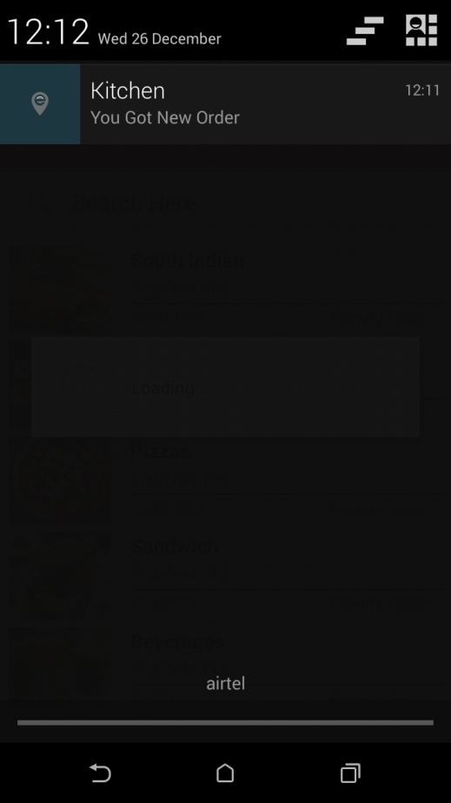 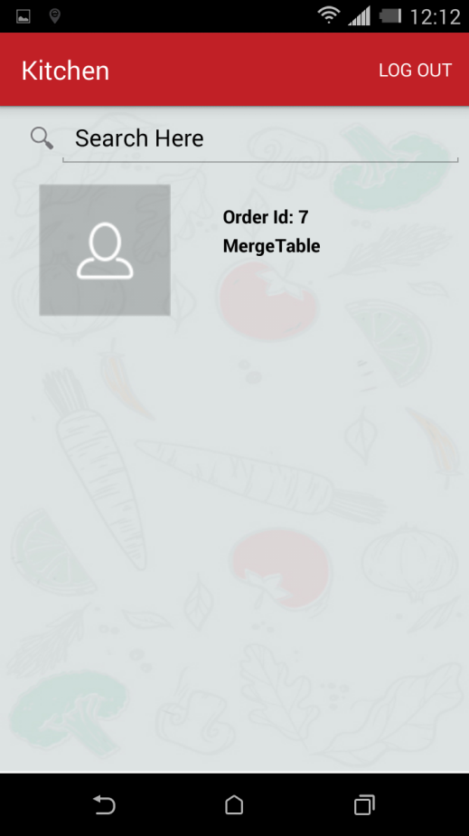

View Order

Kitchen got notification about New Order

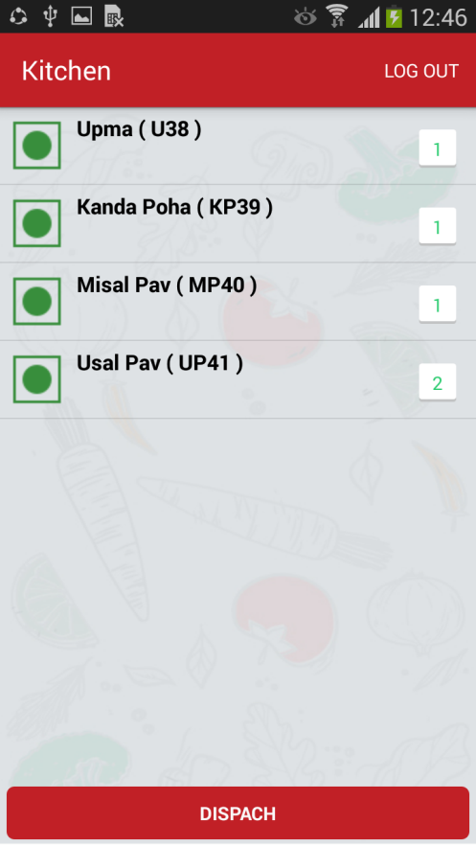 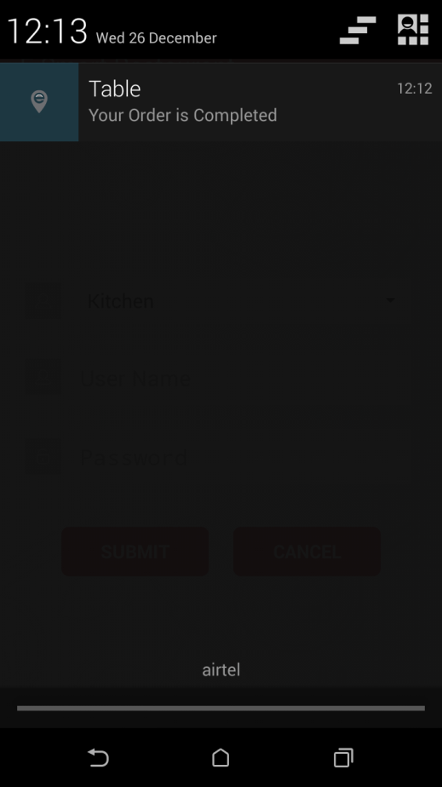

Waiter will receive Notification of completed order.

Dispatch order when get ready